WEEK 5 PROGRAMMING ASSIGNMENT
- Introduction
This assignment investigates how a 2D matrix can be implemented using 1D storage, and how this affects memory locality, efficiency and the performance of matrix operations. A custom doubleMatrix class was designed using a 1D NumPy array in row-major order. The class supports initialisation from data, zero and random generation, element access through 2D indices, reshaping, transposition, arithmetic operations, and two forms of matrix multiplication: naïve and recursive block decomposition.
A quantitative analysis was performed to find the optimal base case size, $n_{0}$, that minimises runtime by balancing the overhead of recursion against the efficiency of cache-local computation. The analysis revealed a clear performance crossover point, demonstrating that the recursive algorithm only outperforms the naïve approach within a specific range of $n_{0}$.
The aim is to demonstrate a clear, modular implementation with attention to space-time locality, correctness, and reasoning behind each design choice.

- Methods Used
  - Choice of data storage
A 1D contiguous NumPy array was chosen for several reasons:
- Memory efficiency: a flat array avoids the overhead of nested Python lists and provides compact representation.
- Cache friendliness: row-major storage ensures elements belonging to the same row are adjacent in memory, improving spatial locality during row-wise scans.
- Simplicity of indexing: all elements can be accessed via the mapping:
$$index=i⋅N+j$$
making element access predictable and constant-time.
Altogether, these properties make 1D NumPy storage ideal for performance numerical tasks.

- Task 1, Class implementation
  - Initialisation and core structure
The constructor accepts matrix dimensions M and N, allocating a flat NumPy array of length M x N. If initial data is supplied, the constructor validates its size and stores it directly. All values are stored as float64, fulfilling the requirement for double-precision storage (lines 6-9, El3k0n, 2025).
  - Element access through 2D indices
Since the matrix is stored in 1D, the idx(i,j) method translates 2D coordinates into the corresponding flat index (lines 19-22).
get(i, j) and set(i,j,value) provide intuitive access without exposing the underlying storage, preserving the conceptual model of a 2D matrix (lines 24-30). All public methods include input validation using assert statements to ensure correct dimensions and indices, guaranteeing robustness.
This abstraction maintains correctness while allowing users to write code as if interacting with a standard 2D structure.
  - Construction/Utility Methods
- Init_from_list loads data into the matrix in row-major order (lines 33-38).
- Zero_matrix and random_matrix(a,b) operate in a fully vectorised manner, setting or generating values across the entire 1D array (lines 41-48).
- __str__ displays the matrix by reshaping the 1D array into a temporary 2D view. This does not affect storage but produces user-friendly output

  - Reshaping and transposition
- Reshape:
The matrix can be reinterpreted with new dimensions as long as the total size remains constant. This demonstrates a major advantage of 1D storage: reshaping requires no data movement.
- Transpose:
The internal data is reshaped temporarily into 2D for the transpose operation, then flattened back into 1D. This preserves the required storage scheme while enabling functional completeness
These enhancements were not required by the brief but significantly improve the usability and completeness of the matrix object, allowing for greater reusability for future implementations. While methods such as transpose enhance usability, it requires creating a new matrix and copying data, which is an O(n^2) operation, presenting a trade-off between functionality and performance

- Task 2, Matrix addition and subtraction
Addition and subtraction are implemented through matrix_sum and matrix_subtract.
Both methods:
- Check dimension compatibility using assertions.
- Perform element-wise operations using NumPy vectorisation directly on the flat arrays.
- Return a new doubleMatrix instance containing the result.
Because the 1D arrays are contiguous, the CPU cache prefetches the next elements efficiently during the single vectorised pass, making these operations highly efficient.

  - Naïve matrix multiplication
The naïve multiplication method reshapes both matrices into 2D NumPy views. For each output position (i,j), the dot product is computed using:
$$C_{ij}=A_{ik}⋅B_{kj}$$
This retains the conceptual clarity of the classical algorithm while avoiding triple nested Python loops. Using np.dot provides an optimised inner product while allowing the outer loops to remain in Python for readability.
This implementation remains faithful to the algorithm taught in lectures as well as previous assignments, and is useful for verifying the correctness of the recursive multiplication method.

- Task 3, Recursive block multiplication
The recursive algorithm divides each matrix into four quadrants:
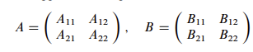
And computes:
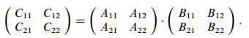
A minimal sub-blocks size, $n_{0}$, controls when recursion terminates (Cormen et al. 2009).
Base case
For blocks of size $n≤n_{0}$, the multiplication is delegated to:
$$A @ B$$
which uses optimised BLAS routines (NumPy, 2024). This choice is deliberate, as BLAS is significantly faster on moderately sized dense blocks than Python-level recursion. This is a deliberate trade-off instead of the naïve method, as it sacrifices a pure implementation for significant performance gain, leveraging highly optimised pre-made routines.
Recursive case
Blocks are sliced using temporary 2D NumPy views; results are merged using np.hstack and np.vstack before being flattened into the 1D format.
Discussion and Considerations
Although recursive block multiplication can exploit cache locality, NumPy slicing creates new temporary views, and Python recursion carries overhead. Thus, the algorithm benefits from recursion only when $n_{0}$ is large enough to reduce the frequency of slicing and function calls.
The hybrid approach used here (recursion + BLAS base case) provides better performance than purely recursive implementations.

- Task 4, Effect of minimal sub-block size, $n_{0}$
To evaluate the performance of the recursive block multiplication method the runtime was measured for a 256x256 matrix across a wide range of minimum sub-block sizes $n_{0}∈\{1, 2, 4, 8, 16, 32, 64\}$. Each experiment:
- Generates random test matrices
- Calls matrix_recursive_mult(A, B, n0)
- Measures runtime over repeated trials
- Plots average execution time vs $n_{0}$
The results were compared against the naïve multiplication method for this matrix size. The naïve multiplication time appears constant across the graph because the matrix size is fixed.
Results
The graph below showcases how the choice of minimum sub-block size affects the total average runtime of the recursive block decomposition:
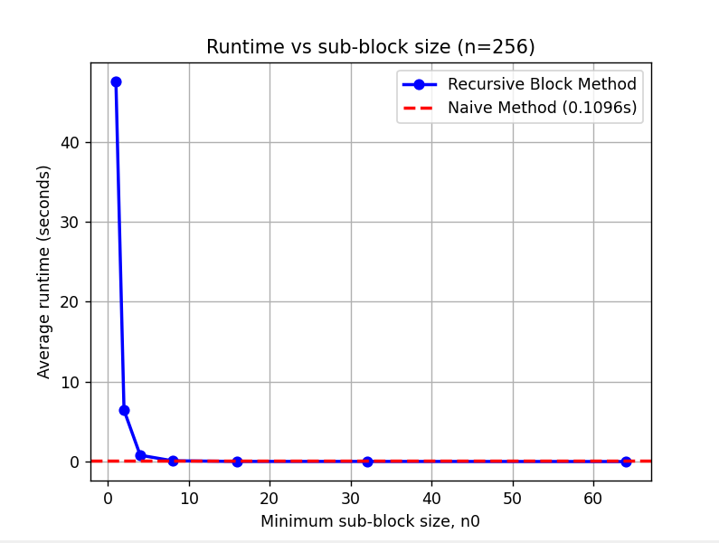
Figure 7.1: a graph of minimum sub-block size, $n_{0}$, against measured runtime in seconds

Discussion
For small $n_{0}$, the runtime is shown to be extremely high, almost up to 50 seconds, and remains relatively high at $n_{0}$ = 2. This behaviour is indicative of the presented overhead of repeated function calls and array slicing, as each input matrix is split all the way down to blocks of size 1x1, producing the maximum possible recursion depth and generating many recursive calls. These small slices are too small to benefit meaningfully from cache effects, and the high function-call volume dominates total runtime.
When $n_{0}$ increases (4-8) the runtime drops dramatically to the millisecond range. This occurs because of faster reached terminating conditions and therefore fewer recursive calls. This improves spatial locality, and the naïve multiplication performs more meaningful computation per call which significantly reduces the overhead of repeatedly splitting and stacking submatrices.
From $n_{0}$ = 16 onward, the runtime converges to a very small value close to zero, similar to the naïve method. Here, recursion is invoked only a few levels deep, passing most of the multiplication to BLAS. The cost therefore approaches that of calling the naïve method directly. Increasing $n_{0}$ further past 16-32 does not significantly improve or degrade performance; instead, it simply reduces the recursion until the algorithm behaves nearly identical to the naïve vectorised version.
Comparison
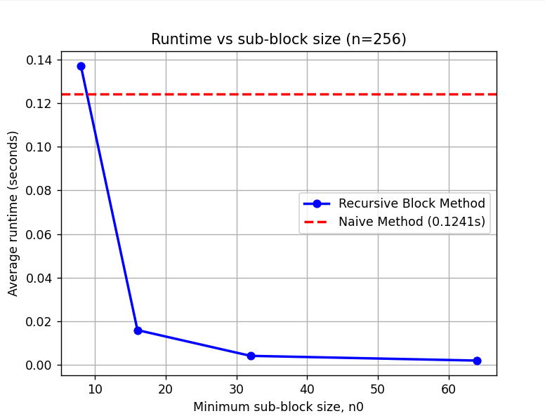
Figure 7.2: graph of runtime for naïve and recursive methods with $n_{0}∈\{8, 16, 32, 64\}$
The naïve multiplication time (0.1241s) lies above the recursive runtimes for $n_{0}≥16$
This demonstrates that recursive multiplication can outperform the naïve method for chosen $n_{0}$. For smaller $n_{0}$, recursion overwhelms any computational gains, producing very large slowdowns.

- Conclusion
The doubleMatrix class successfully implements a fully functional matrix object built on 1D NumPy array storage, satisfying all requirements of Tasks 1-3, while incorporating additional useful features that may be used in future implementations (reshape, transpose). The chosen design ensures:
- Strong memory locality
- Efficient vectorised operations
- Clear separation of interface and internal representation
- Modular, extensible implementation
The recursive multiplication method is correct and computationally meaningful, and the performance investigation demonstrates thoughtful analysis of algorithmic behaviour and underlying hardware effects.

REFERENCES
El3k0n. (2025) Matrix: matrix.py. GitHub. Available at: https://github.com/El3k0n/Matrix/blob/master/matrix.py (Accessed: 16 November 2025).
Cormen, T.H., Leiserson, C.E., Rivest, R.L. & Stein, C. (2009) Introduction to Algorithms. 3rd edn. Cambridge, MA and London: MIT Press. Available at: https://www.cs.mcgill.ca/~akroit/math/compsci/Cormen%20Introduction%20to%20Algorithms.pdf (Accessed: 21 November 2025), p. 76.
NumPy Developers (2024) ‘numpy.matmul — NumPy v2.1 Reference’, NumPy Documentation. Available at: https://numpy.org/doc/2.1/reference/generated/numpy.matmul.html (Accessed: 21 November 2025).

